REPORT ON POWER BI DASHBORD

* Lode the data
* Checking column Quality
* Creating Measures or helping column
* Creating new measure Total Employees using

Total Employee = COUNTROWS('Employee-Attrition')

* New measure for Total Attrition
* Total Attrition = CALCULATE([Total Employee],FILTER('Employee-Attrition',

'Employee-Attrition'[Attrition]="yes"

))

Similarly, we get female attrition by

% Female Attrition =

VAR Female_Attrition=CALCULATE([Total Attrition],FILTER('Employee-Attrition','Employee-Attrition'

[Gender]="Female"

   )

)

VAR Total_Attrition=[Total Attrition]

RETURN

DIVIDE(Female_Attrition,Total_Attrition,0)

And male attrition from

% male Attrition =

VAR male_Attrition=CALCULATE([Total Attrition],FILTER('Employee-Attrition','Employee-Attrition'

[Gender]="male"

   )

)

VAR Total_Attrition=[Total Attrition]

RETURN

DIVIDE(male_Attrition,Total_Attrition,0)

* And % Attrition

% Attrition = DIVIDE([Total Attrition],[Total Employee],0)

* Now we will find out attrition according to the departments

For Human Resources

Human Resources =

CALCULATE([Total Employee],FILTER('Employee-Attrition',

'Employee-Attrition'[Department]="Human Resources"

))

For Research & Development

Research & Development =

CALCULATE([Total Employee],FILTER('Employee-Attrition',

'Employee-Attrition'[Department]="Research & Development"

))

For sales =

CALCULATE([Total Employee],FILTER('Employee-Attrition',

'Employee-Attrition'[Department]="sales"

))

Again a new measure

Remain Human Resources = [Total Attrition]-[Human Resources]

Remain Research & Development = [Total Attrition]-[Research & Development]

Remain sales = [Total Attrition]-[sales]

* Now creating a folder for the department and adding all these measures which we have created
* Now from distance from home column we will create new column distance status by sorting the distance from home column
* Similarly, we sort the columns and create new columns from Total Working years

working groups, Job satisfaction to Job satisfaction status and age to age sort, Percentage salary hike to salary hike, Work life balance to work life status etc.,

* And we create bar, pie, donut charts according to the data

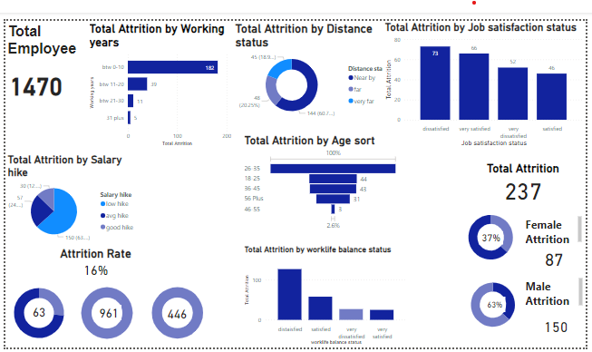

From the above we can observe

* Total employee are 1470
* Total Attrition by distance we can see nearby people attrition is more nearly 60% and far and very far are 20.25% and 19.75%
* From the salary we can observe there is very low hike 150 attrition and avg hike 57 attrition ,30 attrition are from good hike.
* Job satisfaction we can see people are highly dissatisfied i.e., 73 satisfied,66 are very satisfied, 52 are very dissatisfied and 46 are satisfied.
* Total Attrition are 237

Female attrition are 87 and male attrition are 150 means male attrition is more when compared to female

* From age group most of the people are from age 25 to 35 there are 116 attrition in this age group and from 18 to 24 there are 44, from 36 to 45 there are 43 attrition ,56 plus 31 attrition and from 46 to 55 there are 3 attrition
* Attrition from work life balance people are dissatisfied ,127 attrition are due to work life balance

Attrition rate is 16% by using % Attrition = DIVIDE([Total Attrition],

[Total Employee],0)

* Now we find attrition by according to department wise

For Human Resources there is more attrition when compared to sales and Research &development

* From working years attrition very high with low working years people from 0 to 10 working years have 182 attrition people and 31 plus there are just 5 attrition.